Customer Segmentation for Flipkart
Objective: Segment Flipkart customers based on their purchasing behavior (e.g., frequency of purchases, average order value, product categories bought) to create personalized marketing strategies and improve sales.
Step 1: Generate Synthetic Data
CustomerID: Unique ID for each customer
Age: Age of the customer
AnnualIncome: Income level of the customer
PurchaseFrequency: Number of purchases made in a year
AvgOrderValue: Average value of each order
PreferredCategory: The product category preferred by the customer (like electronics, fashion, home goods, etc.)
DiscountSensitivity: How sensitive the customer is to discounts (higher value = more sensitive)
Step 2: Apply K-Means Clustering
We'll use the Elbow Method to determine the optimal number of clusters (K) and then apply K-Means clustering to segment customers into different groups.
import pandas as pd
import numpy as np
from sklearn.cluster import KMeans
from sklearn.preprocessing import StandardScaler
import matplotlib.pyplot as plt
# Step 1: Generate synthetic dataset for Flipkart customers
np.random.seed(42)
# Increase customer count to 10,000
customer_count = 10000
# Randomly generating data for features
age = np.random.randint(18, 65, customer_count)
annual_income = np.random.randint(300000, 1500000, customer_count)
purchase_frequency = np.random.randint(1, 20, customer_count)
avg_order_value = np.random.randint(500, 10000, customer_count)
preferred_category = np.random.choice(['Electronics', 'Fashion', 'HomeGoods', 'Groceries', 'Books'], customer_count)
discount_sensitivity = np.random.uniform(0.1, 1.0, customer_count)
# Create the dataframe
data = pd.DataFrame({
'CustomerID': range(1, customer_count + 1),
'Age': age,
'AnnualIncome': annual_income,
'PurchaseFrequency': purchase_frequency,
'AvgOrderValue': avg_order_value,
'PreferredCategory': preferred_category,
'DiscountSensitivity': discount_sensitivity
})
# Save the generated data to CSV
data.to_csv('flipkart_customers.csv', index=False)
print("Synthetic data saved to 'flipkart_customers.csv'.")
# Step 2: Preprocess the data (only numeric features for clustering)
numeric_data = data[['Age', 'AnnualIncome', 'PurchaseFrequency', 'AvgOrderValue', 'DiscountSensitivity']]
# Standardize the data
scaler = StandardScaler()
scaled_data = scaler.fit_transform(numeric_data)
# Step 3: Elbow Method to determine the optimal number of clusters (K)
wcss = []
for i in range(1, 11):
kmeans = KMeans(n_clusters=i, random_state=42, n_init=10)
kmeans.fit(scaled_data)
wcss.append(kmeans.inertia_)
# Plot the Elbow Method to find the optimal K
plt.figure(figsize=(8, 6))
plt.plot(range(1, 11), wcss, marker='o')
plt.title('Elbow Method for Optimal K')
plt.xlabel('Number of Clusters')
plt.ylabel('WCSS (Inertia)')
plt.grid(True)
plt.show()
# Step 4: Apply K-Means with the selected number of clusters (e.g., K=4)
optimal_k = 4 # Based on the elbow plot
kmeans = KMeans(n_clusters=optimal_k, random_state=42, n_init=10)
data['Cluster'] = kmeans.fit_predict(scaled_data)
# Step 5: Show the first few rows of the dataset with cluster labels
print(data.head())
# Step 6: Cluster insights (mean of numeric features within each cluster)
# Exclude non-numeric columns like 'PreferredCategory' from aggregation
numeric_columns = ['Age', 'AnnualIncome', 'PurchaseFrequency', 'AvgOrderValue', 'DiscountSensitivity']
cluster_insights = data.groupby('Cluster')[numeric_columns].mean()
# Display the cluster insights
print("\nCluster Insights (Average Features per Cluster):")
print(cluster_insights)
# Save clustered data to CSV
data.to_csv('flipkart_clustered_customers.csv', index=False)
print("Clustered data saved to 'flipkart_clustered_customers.csv'.")
Synthetic data saved to 'flipkart_customers.csv'.
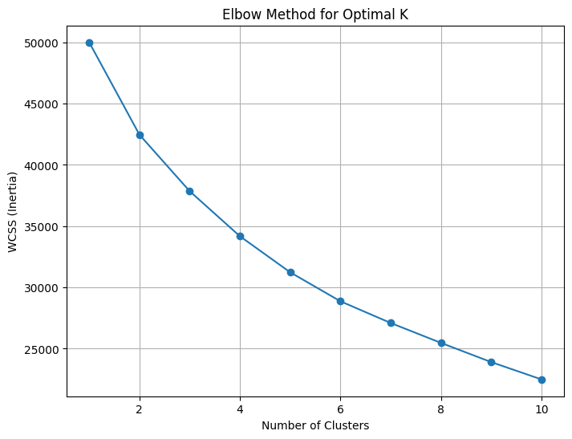
CustomerID Age AnnualIncome PurchaseFrequency AvgOrderValue \
0 1 56 576999 6 9079
1 2 46 729385 19 1297
2 3 32 477476 10 6213
3 4 60 1499217 1 7811
4 5 25 949362 16 4520
PreferredCategory DiscountSensitivity Cluster
0 Books 0.196120 2
1 Groceries 0.625652 2
2 Fashion 0.143802 3
3 HomeGoods 0.944786 1
4 Books 0.395962 0
Cluster Insights (Average Features per Cluster):
Age AnnualIncome PurchaseFrequency AvgOrderValue \
Cluster
0 33.513900 1.181457e+06 14.227413 5246.917375
1 49.989510 1.115350e+06 5.422688 5049.810023
2 51.628015 6.380413e+05 13.575963 5464.926788
3 29.546704 6.406867e+05 7.045693 5198.655884
DiscountSensitivity
Cluster
0 0.562846
1 0.533552
2 0.558123
3 0.555127
Clustered data saved to 'flipkart_clustered_customers.csv'.

# Visualizing the clusters
plt.figure(figsize=(8, 6))
plt.scatter(data['Age'], data['AnnualIncome'], c=data['Cluster'], cmap='viridis', s=50)
plt.title('Customer Segments based on Age and Income')
plt.xlabel('Age')
plt.ylabel('Annual Income')
plt.colorbar(label='Cluster')
plt.show()
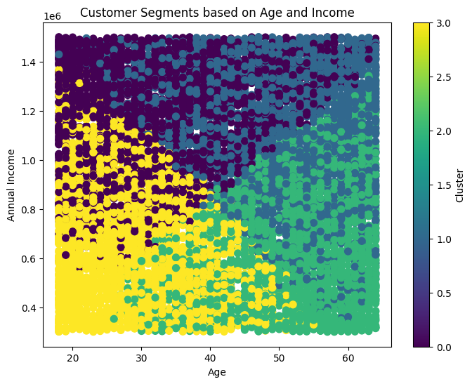
Data Generation:
We generate a synthetic dataset of 1,000 customers with random values for each feature.
Age, AnnualIncome, PurchaseFrequency, AvgOrderValue, DiscountSensitivity are numerical, while PreferredCategory is categorical (representing product preferences).
Data Preprocessing:
We scale the numerical data (using StandardScaler) to ensure all features contribute equally to the clustering.
Elbow Method:
We calculate WCSS (Within-Cluster Sum of Squares) for K values from 1 to 10 and plot it.
We look for the "elbow" point, which will help us select the optimal number of clusters. Ideally, this should be around K=3 or K=4, meaning after that point, the inertia (WCSS) will not decrease significantly.
K-Means Clustering:
We apply K-Means clustering with the optimal K (say K=4) and assign each customer to a cluster.
Cluster Insights:
We group the data by clusters and calculate the average values of each feature for each cluster. This will give us insights into the characteristics of each customer segment.
Cluster 0: Young customers with moderate income and moderate purchase frequency, but lower discount sensitivity.
Cluster 1: High-income, high-purchase frequency, discount-sensitive customers (ideal for promotional campaigns).
Cluster 2: Wealthy, high spenders, low discount sensitivity.
Cluster 3: Middle-income customers, moderate discount sensitivity, low purchase frequency.
K-Means uses (Euclidean) distance to measure the similarity between points. If features have different scales, those with larger values will dominate the clustering process, leading to biased clusters.
Example:
Feature A (salary): 50,000 to 1,00,000
Feature B (age): 20 to 60
Salary has a much larger range than age, so K-Means will give more importance to salary when computing distances.
To fix this, we scale the data to ensure all features contribute equally.

Business Benefits of Clustering:
Personalized Marketing:
Based on the clusters, Flipkart can target customers with personalized marketing. For example, Cluster 1 can be targeted with discounts and promotions, while Cluster 2 can be offered premium products.
Improved Inventory Management:
By understanding which products appeal to which customer segments, Flipkart can optimize its inventory by focusing on the products that are popular among each cluster.
Customer Retention:
Clusters that exhibit high purchase frequency and discount sensitivity can be targeted for loyalty programs, while high-income clusters can be offered exclusive membership.
Sales Strategy:
High-value clusters can be offered up-selling opportunities (higher-end products), while price-sensitive clusters can receive discount-based promotions.
Conclusion:
This K-Means clustering approach can be applied to segment customers based on purchasing behavior, and the insights can be used to create targeted marketing strategies and improve business decisions. The process is simple and actionable, and the results are beneficial for optimizing customer experience and sales strategies.
Now for 30 customers:
import pandas as pd
import numpy as np
import matplotlib.pyplot as plt
from sklearn.cluster import KMeans
from sklearn.preprocessing import StandardScaler
# Step 1: Generate synthetic dataset for Flipkart customers (Only 30 customers)
np.random.seed(42)
customer_count = 30
# Randomly generating data for features
age = np.random.randint(18, 65, customer_count)
annual_income = np.random.randint(300000, 1500000, customer_count)
purchase_frequency = np.random.randint(1, 20, customer_count)
avg_order_value = np.random.randint(500, 10000, customer_count)
preferred_category = np.random.choice(['Electronics', 'Fashion', 'HomeGoods', 'Groceries', 'Books'], customer_count)
discount_sensitivity = np.random.uniform(0.1, 1.0, customer_count)
# Create the dataframe
data = pd.DataFrame({
'CustomerID': range(1, customer_count + 1),
'Age': age,
'AnnualIncome': annual_income,
'PurchaseFrequency': purchase_frequency,
'AvgOrderValue': avg_order_value,
'PreferredCategory': preferred_category,
'DiscountSensitivity': discount_sensitivity
})
# Save the generated data to CSV
data.to_csv('flipkart_customers_30.csv', index=False)
print("Synthetic data for 30 customers saved to 'flipkart_customers_30.csv'.")
# Step 2: Preprocess the data (only numeric features for clustering)
numeric_data = data[['Age', 'AnnualIncome', 'PurchaseFrequency', 'AvgOrderValue', 'DiscountSensitivity']]
# Standardize the data
scaler = StandardScaler()
scaled_data = scaler.fit_transform(numeric_data)
# Step 3: Elbow Method to determine the optimal number of clusters (K)
wcss = []
for i in range(1, 11):
kmeans = KMeans(n_clusters=i, random_state=42, n_init=10)
kmeans.fit(scaled_data)
wcss.append(kmeans.inertia_)
# Plot the Elbow Method to find the optimal K
plt.figure(figsize=(8, 6))
plt.plot(range(1, 11), wcss, marker='o', linestyle='--', color='b')
plt.title('Elbow Method for Optimal K (30 Customers)')
plt.xlabel('Number of Clusters')
plt.ylabel('WCSS (Inertia)')
plt.grid(True)
plt.show()
# Step 4: Apply K-Means with the selected number of clusters (K=3 or 4)
optimal_k = 3 # Adjust based on the elbow plot
kmeans = KMeans(n_clusters=optimal_k, random_state=42, n_init=10)
data['Cluster'] = kmeans.fit_predict(scaled_data)
# Step 5: Show the first few rows of the dataset with cluster labels
print("\nClustered Data:")
print(data)
# Step 6: Cluster insights (mean of numeric features within each cluster)
numeric_columns = ['Age', 'AnnualIncome', 'PurchaseFrequency', 'AvgOrderValue', 'DiscountSensitivity']
cluster_insights = data.groupby('Cluster')[numeric_columns].mean()
# Display the cluster insights
print("\nCluster Insights (Average Features per Cluster):")
print(cluster_insights)
# Save clustered data to CSV
data.to_csv('flipkart_clustered_customers_30.csv', index=False)
print("\nClustered data saved to 'flipkart_clustered_customers_30.csv'.")
Synthetic data for 30 customers saved to 'flipkart_customers_30.csv'.
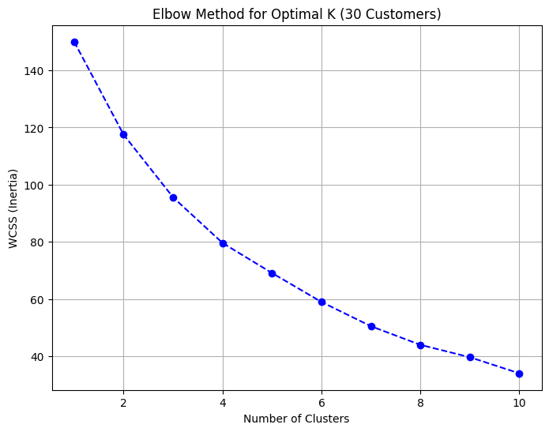
Clustered Data:
CustomerID Age AnnualIncome PurchaseFrequency AvgOrderValue \
0 1 56 456730 14 8506
1 2 46 1498079 17 3068
2 3 32 954811 4 5963
3 4 60 827035 18 2527
4 5 25 948143 8 3195
PreferredCategory DiscountSensitivity Cluster
0 Electronics 0.391911 1
1 Fashion 0.209879 2
2 Fashion 0.420668 1
3 Groceries 0.916146 0
4 Books 0.344919 2
5 HomeGoods 0.682921 1
6 Electronics 0.100468 1
7 Groceries 0.417312 1
Cluster Insights (Average Features per Cluster):
Age AnnualIncome PurchaseFrequency AvgOrderValue \
Cluster
0 36.285714 9.072700e+05 15.714286 5398.142857
1 44.125000 7.393701e+05 7.750000 7146.687500
2 40.142857 1.009533e+06 12.428571 2359.857143
DiscountSensitivity
Cluster
0 0.791965
1 0.387120
2 0.273192
Clustered data saved to 'flipkart_clustered_customers_30.csv'.
# Visualizing the clusters
plt.figure(figsize=(8, 6))
plt.scatter(data['Age'], data['AnnualIncome'], c=data['Cluster'], cmap='viridis', s=50)
plt.title('Customer Segments based on Age and Income')
plt.xlabel('Age')
plt.ylabel('Annual Income')
plt.colorbar(label='Cluster')
plt.show()
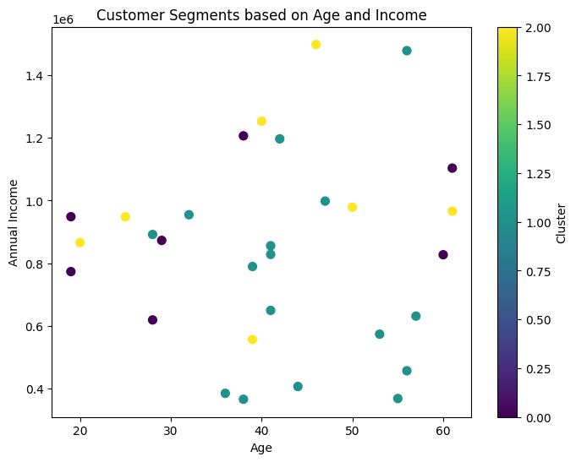
Now with customer names:
import pandas as pd
import numpy as np
import matplotlib.pyplot as plt
import seaborn as sns
from sklearn.cluster import KMeans
from sklearn.preprocessing import StandardScaler
# Step 1: Generate synthetic dataset for Flipkart customers (Only 30 customers)
np.random.seed(42)
customer_count = 30
# Sample Indian customer names
customer_names = [
"Aarav", "Vihaan", "Ishaan", "Kabir", "Aryan", "Anaya", "Myra", "Aadhya", "Siya", "Riya",
"Neha", "Rohan", "Ritik", "Sanya", "Harsh", "Tushar", "Soham", "Ira", "Vivaan", "Kavya",
"Yash", "Kunal", "Raj", "Tanvi", "Krishna", "Aditya", "Meera", "Dev", "Anjali", "Sakshi"
]
# Generating random customer data
age = np.random.randint(18, 65, customer_count)
annual_income = np.random.randint(300000, 1500000, customer_count)
purchase_frequency = np.random.randint(1, 20, customer_count)
avg_order_value = np.random.randint(500, 10000, customer_count)
preferred_category = np.random.choice(['Electronics', 'Fashion', 'HomeGoods', 'Groceries', 'Books'], customer_count)
discount_sensitivity = np.random.uniform(0.1, 1.0, customer_count)
# Create DataFrame
data = pd.DataFrame({
'CustomerID': range(1, customer_count + 1),
'Name': customer_names,
'Age': age,
'AnnualIncome': annual_income,
'PurchaseFrequency': purchase_frequency,
'AvgOrderValue': avg_order_value,
'PreferredCategory': preferred_category,
'DiscountSensitivity': discount_sensitivity
})
# Save the generated data to CSV
data.to_csv('flipkart_customers_30.csv', index=False)
print("Synthetic data saved to 'flipkart_customers_30.csv'.")
# Step 2: Preprocess the data (only numeric features for clustering)
numeric_data = data[['Age', 'AnnualIncome', 'PurchaseFrequency', 'AvgOrderValue', 'DiscountSensitivity']]
# Standardize the data
scaler = StandardScaler()
scaled_data = scaler.fit_transform(numeric_data)
# Step 3: Elbow Method to determine the optimal number of clusters (K)
wcss = []
for i in range(1, 11):
kmeans = KMeans(n_clusters=i, random_state=42, n_init=10)
kmeans.fit(scaled_data)
wcss.append(kmeans.inertia_)
# Plot the Elbow Method
plt.figure(figsize=(8, 6))
plt.plot(range(1, 11), wcss, marker='o', linestyle='--', color='b')
plt.title('Elbow Method for Optimal K (30 Customers)')
plt.xlabel('Number of Clusters')
plt.ylabel('WCSS (Inertia)')
plt.grid(True)
plt.show()
# Step 4: Apply K-Means with the selected number of clusters (K=3 or 4)
optimal_k = 3 # Adjust based on the elbow plot
kmeans = KMeans(n_clusters=optimal_k, random_state=42, n_init=10)
data['Cluster'] = kmeans.fit_predict(scaled_data)
# Step 5: Show the first few rows of the dataset with cluster labels
print("\nClustered Data:")
print(data)
# Step 6: Cluster insights (mean of numeric features within each cluster)
numeric_columns = ['Age', 'AnnualIncome', 'PurchaseFrequency', 'AvgOrderValue', 'DiscountSensitivity']
cluster_insights = data.groupby('Cluster')[numeric_columns].mean()
# Display the cluster insights
print("\nCluster Insights (Average Features per Cluster):")
print(cluster_insights)
# Save clustered data to CSV
data.to_csv('flipkart_clustered_customers_30.csv', index=False)
print("\nClustered data saved to 'flipkart_clustered_customers_30.csv'.")
# Step 7: Visualizing the Clusters (Age vs Annual Income)
plt.figure(figsize=(10, 6))
sns.scatterplot(
x=data['Age'], y=data['AnnualIncome'], hue=data['Cluster'], palette='viridis', s=100
)
# Mark centroids
centroids = scaler.inverse_transform(kmeans.cluster_centers_)
plt.scatter(centroids[:, 0], centroids[:, 1], marker='X', s=200, c='red', label='Centroids')
# Add customer names to points
for i in range(customer_count):
plt.text(data['Age'][i], data['AnnualIncome'][i], data['Name'][i], fontsize=9, ha='right')
plt.title('Customer Segments based on Age and Income')
plt.xlabel('Age')
plt.ylabel('Annual Income')
plt.legend()
plt.show()
Synthetic data saved to 'flipkart_customers_30.csv'.

Clustered Data:
CustomerID Name Age AnnualIncome PurchaseFrequency AvgOrderValue \
0 1 Aarav 56 456730 14 8506
1 2 Vihaan 46 1498079 17 3068
2 3 Ishaan 32 954811 4 5963
3 4 Kabir 60 827035 18 2527
4 5 Aryan 25 948143 8
PreferredCategory DiscountSensitivity Cluster
0 Electronics 0.391911 1
1 Fashion 0.209879 2
2 Fashion 0.420668 1
3 Groceries 0.916146 0
4 Books 0.344919 2
5 HomeGoods 0.682921 1
6 Electronics 0.100468 1
Cluster Insights (Average Features per Cluster):
Age AnnualIncome PurchaseFrequency AvgOrderValue \
Cluster
0 36.285714 9.072700e+05 15.714286 5398.142857
1 44.125000 7.393701e+05 7.750000 7146.687500
2 40.142857 1.009533e+06 12.428571 2359.857143
DiscountSensitivity
Cluster
0 0.791965
1 0.387120
2 0.273192
Clustered data saved to 'flipkart_clustered_customers_30.csv'.
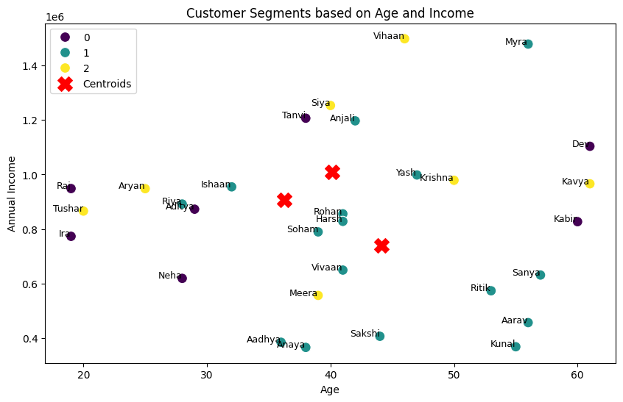
# THE END

